Running Head: CONSULTANCY REPORT

Consultancy Report – YCL’s Overseas Expansion
[Name of the Writer]
[Name of the Institution]
[Name of the Subject]
[Date]

- Introduction
YCL has been developed with the aim to offer specialized management solutions to corporate clients in the IT sector. With trained and skillful workforce of 20 employees the firm has been able to build strong brand reputation. The company has been working for past 10 years and has gained sufficient experience by delivering innovative management solution to its prestigious international clients. Since, YCL has worked with several multinational companies it has the strength in understanding the expectation of foreign clients. Thus, expanding in the overseas market can provide further opportunities for growth to the firm.
The increase demand for technology in the GCC has promoted double-digit growth in the sector. It is expected that the information and communication (ICT) sector in the region will grow by 10 to 25% next year due to increased use of technology, such as cloud computing or analytics in the finance, oil and gas, telecommunication and government services. Therefore, it can provide great opportunities to YCL to provide its innovative solutions in this region with its expertise in technology-related projects.
Moreover, it would be more feasible to target the Saudi Arabia, as innovation and technology is integral to the long term vision of the country set in the National Science, Technology and Innovation Plan (NSTIP) (Kahtani & Khan, 2014). The main purpose is to develop a knowledge-based society. Many initiatives have been taken along with development of support systems to build human resource capacities, setting up research and innovation facilities in universities and enhancing the legal framework. However, the economy still lacks the talent needed for exploiting these opportunities. Hence, YCL can utilize its resources and skills to provide innovative management solutions to organizations operating in the industry and other new entrants in the industry can be potential clients for YCL.
1.1 Strengths
YCL has in-depth IT expertise that has enabled the firm to provide internal technology teams with customized, objective technology strategy and consulting services. The company works with high-technology clients that have high expectations of deploying technology effectively and efficiently. YCL has served high-tech multinational companies through which it has been possible for the firm to develop understanding of the dynamic nature of technology landscape. Their clients will be assisted in implementing lean approaches for management the data center landscape. Corporations can seek assistance from YCL for implementing private cloud-solutions. They can help in establishing comprehensive IT strategies for improving their performance. Additionally, with the help of YCL companies can successful management and design ERP implementations. Hence, with rapid development in technology, YCL can provide firms with management solutions that are seeking assistance for their technology-related projects.

1.2 Weaknesses
In order to expand successfully in the Saudi market, it is important for YCL to have sufficient resources. Currently, the company lacks financial and human resources, which are necessary to expand business operations in the international market. The management also does not have the information that can help in managing cultural differences by entering in the region. These factors can hinder their ability to achieve rapid growth in the industry; therefore, the company must address them by developing an understanding of the Saudi business climate and hiring workforce.

1.3 Doing Business in Saudi Arabia
The graph below indicates a comparison of different regions, where opportunities lie for business to expand their activities. The figure shows that while the performance of other regions have remained constant; the Real GDP growth (%) in the Middle East region has been rising over the past years and is expected to increase further in the coming years.
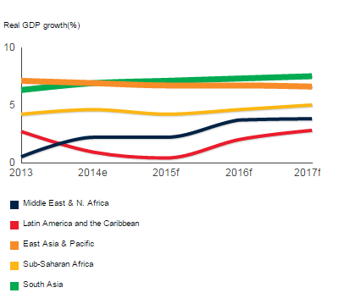
The table below also indicates the potential of the Middle East region in comparison to other regions including Latin America, Africa and Asia.
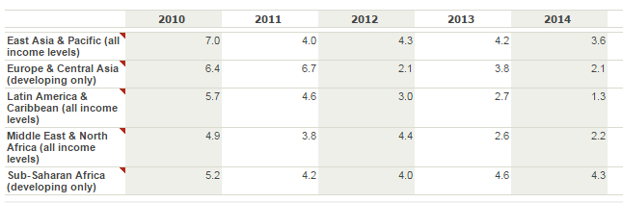
As the oil reserves have increased in Saudi Arabia, its status in the global economy has also risen sharply and it currently offers several opportunities to international firms for growth and expansion (Hudhaif & Alkubeyyer, 2011). Considering the rising GDP of the country, YCL can seek strategic partnership in the country to expand its business. The graph below illustrates the changes in GDP growth rate in Saudi Arabia, over the past years the country faced challenges; however, it has improved its performance last year, which is expected to increase in the future. 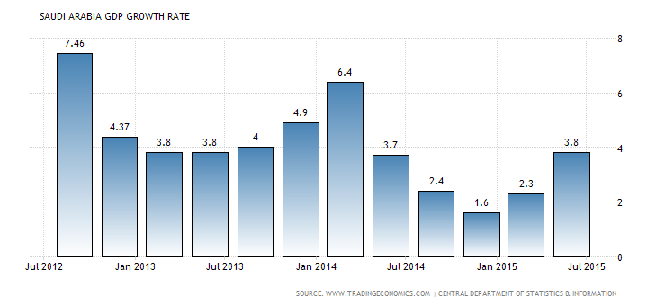
Moreover, at the same time there are various issues that organizations must address when entering into the country such as poorly developed education sector with insufficient legal regulations and increasing political risk. Thus, these are some of the important factors that YCL need to consider and analyze the strategy of other multinationals entering into the country. Saudi Arabia has continued to experience an average economic growth of 5% since 2003. Even during the global credit crunch in 2007-2008, the country achieved a 3.4% economic growth. Favourable policies have been developed in the region to encourage investment in Research and Development. Additionally, corporate tax laws have also motivated firms to invest in R&D in specific sectors (Asad, 2012).There was a significant increase in R&D in the country which grew by an estimated 5.2% in 2012. Therefore, YCL can tremendous opportunities as it will be providing services in this sector and assisting firms to achieve rapid growth
Government provides sufficient support to private sector through economic measures particularly in the sector of power, petrochemicals and oil (Nalband & Amri, 2013). Additionally, to attract foreign direct investment in the country, various steps have been taken by the government to ease its foreign investment policies. These factors can act in favor of YCL, as they are operating in the telecommunication sector, they can receive governmental support to expand their operations (Otaibi, Alharbi & Almeleehan, 2015). Furthermore, being a UK multinational firm government would be keen to attract investment in their country from such a firm.

- Case Study
2.1 IBM
2.1.1 Overview
IBM formed a joint collaboration with Mobily in Saudi Arabia to bring the company’s intellectual capital, solutions, stringent processes and its delivery capabilities to the Kingdom of Saudi Arabia. This alliance, as a result has facilitated in bringing the cloud-based solutions that are specifically developed to cater the needs of clients in Saudi Arabia. Furthermore, in order to meet the need of larger enterprises both the companies will make combine efforts for delivering tailor-made solutions to meet specific client demands.

2.1.2 IBM in Saudi Arabia
The company is providing solutions combine services, software and systems for all businesses irrespective of their size. The services of the company range from business consulting in strategy and transforming to IT services around cloud, business continuity and security. IBM also offers software applications that address everything from data storage to collaboration tools, data centre management and software development. Other services include servers and storage systems that are designed to support all of these and meet the infrastructure needs of companies with their development.

2.1.3 Products/ Services
As there has been exponential growth in the data and the regulatory requirements are increasing continuously, it is becoming important for companies to protect their data and applications in a cost effective manner. Firms require a solution through which they can easily restore, back-up and maintain access to critical data. Thus, IBM provides technological solutions such as SmartCloud Managed Backup which is a cloud-based service through which companies can ensure security-rich, managed protection of critical data. Corporations in Saudi Arabia can receive on-site and off-site data backup for reducing operational risk and cost of ownership.

2.1.4 Joint Venture
As a result of skills shortage for security practitioners, corporate clients seek a trusted partner who can provide managed security solutions. In Saudi Arabia there are 58% businesses that are unable to find the right people with necessary skills, 53% of the businesses do not have the ability to measure their existing security efforts and 66% are still struggling with an understaffed IT team. Thus, IBM has partnered with Mobily in the region to offer unparalleled managed services and security intelligence. The company has a broad base of consulting services for delivering end-to-end solutions. Corporate clients will be confident, as they know that IBM security services are backed by the company’s strong market leadership and analyst recognition.

Conclusion
Companies in Saudi Arabia are struggling with the ability to have strategic IT solutions for their businesses to ensure data security and its management. They do not have human resource with necessary technological expertise; therefore, IBM has entered in the market and has remained successful by partnering with Mobily to deliver its IT solutions to clients. The company has a strong market reputation due to its exceptional services and experience over the past years. Therefore, YCL with its expertise and experience can also expand successfully in the region.
2.2 Boeing
2.2.1 Commercial Overview
Boeing is the world's leading aerospace company and the largest manufacturer of commercial jetliners and military aircraft combined. The company is also engaged in desgining and manufacturing rotorcraft, missiles, launch vehicles, defense system and advance information and communication systems. It is the major service provider to NASA and therefore, is the only contractor for the International Space Station. Boeing is also involved in providing various military and commercial airline support services. The customers of Boeing are located in 150 countries, to which the company is providing its products and support services. It is one of the largest exporters in US in terms of sales. The company has been the leader in the aerospace industry and has dominated the market through continuous innovation.

    - Company Background
Boeing Company has been enjoying a strong and long-standing relationship with the KSA. The partnership was initiated in the year1945, when the US president presented a Dakota airplane to the King Abdulaziz Al-Saud. As a result of this event, the relationship between Boeing and Saudi Arabia were strengthened. Since then, the company has been expanding its relationships with the Saudi civil and defense authorities. It also developed strong connection with the private sector. Boeing Middle East Limited in Riyadh was established in 1982 with 100% Boeing ownership

    - Partnering with Saudia Aerospace Engineering Industries and Alsalam Aircraft Co.
Boeing has partnered with companies in Saudi Arabia for creating a joint venture company to provide in-country repair, maintenance and overhaul of helicopters. It has partnered with the Saudia Aerospace Engineering Industries and Alsalam Aircraft Co. To create a new firm called the Saudi Rotorcraft Support Center. It will be initially located in Riyadh and Jeddah. Boeing has continued to offer customers with highest level of support and services. This company has been built on the basis of the long partnership between Boeing and Saudi Arabia. The center aims to enhance the readiness of the rotorcraft personnel and fleet in Saudi Arabia. The purpose is to serve the commercial and military helicopters in KSA.

    - Global Corporate Citizenship
One of the core values of the company is its “global corporate citizenship. Boeing considers the communities in which it operates, as its most important stakeholders. The company believes that corporate citizenship is equally important to remain successful, as it to have the relevant expertise in technology and flight. Boeing has applied its unique core competencies for community engagement and delivering sustainable and measureable social development.
The company has become an active community member in Saudi Arabia by focusing on education, health and human services and also by providing support to several non-profit organizations. For instance, it supports the learning disability in the King Saman Center for Disability Research. It has also participated actively in Janadriyah Cultural Heritage Festival over the past three consecutive years for celebrating the culture of Saudi Arabia and to showcase company’s products and services.
Conclusion
Boeing has been operating KSA over the past few decades it has been able to remain successful in the region. The company has partnered with Saudia Aerospace Engineering Industries and Alsalam Aircraft co. for developing a new firm in the region. With its ability to serve the community and remain committed to it, Boeing has achieved tremendous growth in the country. Thus, YCL needs to consider this region, as international firms have formed successful strategic partnership in the region for delivering their products and services. YCL with its strong and prestigious clients list can also target firms in this region for expanding its operations. It can remain committed to the community through corporate citizenship to establish strong brand reputation.

3. Potential Impact on YCL’s Existing Business Operations
3.1 Cultural Management
There are various cultural differences between the two countries. It is essential for YCL to understand these differences and manage them to remain successful. The figure below illustrates the differences between the countries using Hofstede’s cultural dimensions. It can be seen that there cultural differences in terms of power distance, where people in Saudi Arabia are more likely to take orders from their managers. With low on individualism, people in the country take responsibility for their fellow members in the group and hence, they can perform well while working in teams. However, as compared to UK the country has scored low on long-term orientation, which means they are more focused on achieving short-term goals. Moreover, along with these factors it is also important to understand the language barriers between the two countries. And, the business environment is mostly based on Islamic regulations that should be taken into consideration.
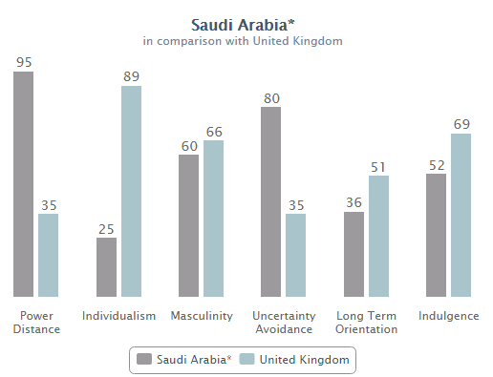

3.2 Change Management
YCL will be required to implement change strategically in the company to expand successfully in Saudi Arabia. Some of the key professionals will be required to be located in Saudi Arabia for training the staff. The management may experience resistance from employees, as they will be unwilling to move to other country. However, it is imperative to overcome this resistance by taking necessary measures such effectively communicating them the need for change and how it will be beneficial for the company and its employees.

3.3 Financial and Human Resources
In order to expand in Saudi Arabia YCL will be required to have additional financial and human capital. There are different sources of finances including internal and external finance. The company can fund its expansion through its retained earnings (internal sources). For obtaining external finances YCL can seek assistance from International Financial Corporation in Saudi Arabia that provides funds to SMEs for promoting economic growth and creation of employment. The company will also be required to hire more employees who must be trained by the existing experienced and skilful human resource.

3.4 Infrastructure Development
It is important to have the necessary infrastructure to facilitate the employees for dealing with the customers. Therefore, YCL will be required to establish physical office to accommodate its workforce. This will facilitate them to communicate with their clients and inform them about the products and services being delivered. All the equipments should be purchased including office supplies to provide them to the employees. Proper documentation must be done for effective management.

4. Evaluation
4.1 Evaluation
YCL must be able to develop thorough understanding of the national business system in the Saudi Arabia, as there are several differences between the two countries. Lessons can be learnt from IBM, as it has been able to expand in the country by partnering with Mobily with its strong brand reputation and being the leader in the
4.2 Evaluation

5. Recommendations

It is important for YCL to understand the business environment of the country for which the management can hire employees that are Saudi nationals and have thorough understanding of the environment. With stability in the legal and political environment of the country Saudi Arabia can provide tremendous opportunities for growth to YCL. YCL can help existing firms to implement latest technology to cater the changing needs of customers and also to enhance their customer services. YCL has been performing well in the UK with its trained employees and detailed information on delivering IT solutions to its clients. The company has gained sufficient experience by working with some of most prestigious clients both national and international. In order to achieve further growth, it plans to expand its operations in the foreign market. Saudi Arabia with substantial economic growth, political stability and ease of regulations has attracted many international companies to invest in the country. Therefore, it can be a good avenue for YCL to start its operations and remain successful. Since, the firm has expertise in technology related projects Saudi Arabia with development in its technology-related industries can provide tremendous opportunities to it. The firm can partner with companies operating in the sector to deliver its services and establish a strong brand name.

